Dialogue System

Scripts that you need:

* NPCInteractionScrpt (Attached to the player)
* NPCDialogueScrpt (Attached to the npc that you want to talk to)
* RaycastItems (Attached to the players camera)

The RaycastItems script is used to determine if the player is looking at an item or a npc etc. If the player is looking at a npc then when they press the E key it will trigger the start of the dialogue.

When the dialogue starts the scripts will check to see if either the player or the npc talks first (this can be set in the inspector)



If the value is true then the player talks first, but if its false the npc will talk first.

After this the Interaction script will then check in the NPCDialogueScrpt to see where in the players dialogue index and NPC’s dialogue index it should start reading the dialogue from. These can be set in the inspector for the NPCDialogueScrpt (note the dialogue index is the position of the dialogue in either the player or NPC’s dialogue list)

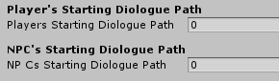

The section of the NPCDialogueScrpt in the inspector labeled “NPC Dialogue Lines” or “Player dialogue lines” are where you enter the dialogue that you want to be said.

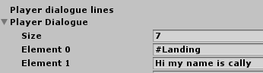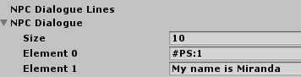

To change the amount of dialogue lines that you want, simply change the number in the box labelled “Size”.

To get the character/player to say basic lines simply input the dialogue into the list and add an extra index at the end which reads #End (more on that in a second)

In order to get the system to do certain special things such as playing sounds, switching who’s talking or looping the dialogue back to a previous point, you need to use certain text triggers these are:

* #PS: (insert number here) / Also known as play sound, the number is the index number of the sound that you want to play in the audio manager.
* #Switch / This one switches the role of talker between the player and npc whenever it is called, but also must be used with the #Landing code to work properly.
* #Landing / this one is used to set the landing point in the next talkers dialogue so that the transition works smoothly.
* #End / this one is used to signify the absolute end of all dialogue and should only be put at the end of the dialogue lists.
* #LP: (insert number here)/ also known as Loop, the number comes from the index number of the dialogue that you want to loop back to (note you can’t loop back to a bit of npc from player dialogue (or vice versa) without also using the #Switch function)
* #Break / signifies a soft end to the dialogue which will enable the player to interact with the npc again and get a new dialogue line)